**RTL CHALLENGE**

**DAY27:-** :- Verilog Code for Implementation of SR Flipflop.

**Software used**:- Xilinx Vivado(2023.1)

**Theory:-**

# Flip-flop:-

Flip-flop is a circuit that maintains a state until directed by input to change the state. A basic flip-flop can be constructed using four-NAND or four-NOR gates. Flip flop is popularly known as the basic digital memory circuit. It has its two states as logic 1(High) and logic 0(low) states. A flip flop is a sequential circuit which consist of single binary state of information or data. The digital circuit is a flip flop which has two outputs and are of opposite states. It is also known as a Bistable Multivibrator.

**Types of flip-flops:**

1. SR Flip Flop
2. JK Flip Flop
3. D Flip Flop
4. T Flip Flop

SR Flip Flop

It is a Flip Flop with two inputs, one is S and other is R.**S** here stands for Set and **R** here stands for Reset. Set basically indicates set the flip flop which means output 1 and reset indicates resetting the flip flop which means output 0. Here clock pulse is supplied to operate this flip flop, hence it is clocked flip flop.

The SR flip flop has two inputs SET ‘S’ and RESET ‘R’. As the name suggests, when S = 1, output Q becomes 1, and when R = 1, output Q becomes 0. The output Q’ is the complement of Q.

## Block Diagram:-

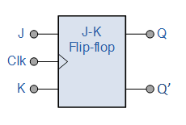

## Truth Table of SR Flip Flop:-

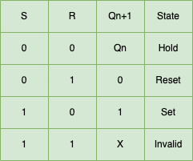

## Characteristic Table of SR Flip Flop

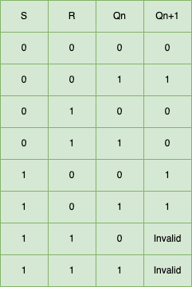

**VERILOG CODE:-**



**TEST BENCH:-**



**OUTPUT:-**

Reset=0 --> q=x, q_bar=x

Reset=1 --> q=x, q_bar=x

s=0, r=0 ,q=0, q_bar=1

s=0, r=1 ,q=0, q_bar=1

s=1, r=0 ,q=0, q_bar=1

s=1, r=1 ,q=0, q_bar=1

$finish called at time : 410 ns

**RTL DESIGN:-**



**OUTPUT WAVEFORM:-**

